When you arrive at the Gallery, walk between the pillars and through the front door. Follow the arrows to the Martin Parr Exhibition.
Manchester Art Gallery
Welcome to Open doors 15th December
Open doors is a creative workshop especially for children and adults with autism and other social communication issues, their families and carers. We open our doors early so that you can come enjoy and explore art together as a family.
This Month’s session is : Saturday 15th December -9.15-11.15
Next month’s session is: Saturday 19th January -9.15-11.15
And then ……………… : Saturday 16th February -9.15-11.15

Please feel free to contact katy McCall on 0161 235 8869 k.mccall1@manchester.gov.uk if you have any questions or would like to find out more

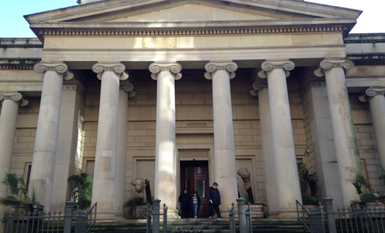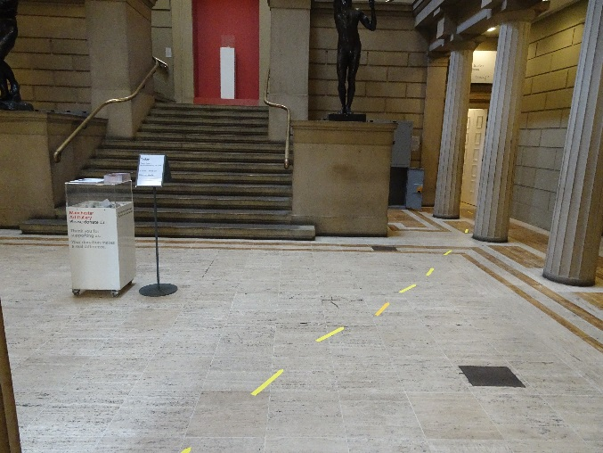
Explore the gallery and make some art
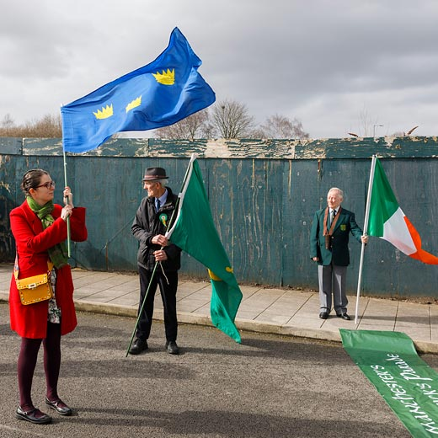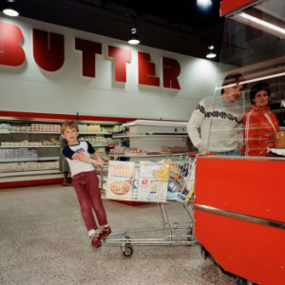
Then come and discover the Clore Studio where there will be artist led activities
Quiet room available if you need a moment out
Please feel free to contact katy McCall on 0161 235 8869 k.mccall1@manchester.gov.uk if you have any questions or would like to find out more. The gallery will be open to the general public at 10. please visit www.manchesterartgallery.org

