Non-fivtionHello!
Reception Newsletter
Hello 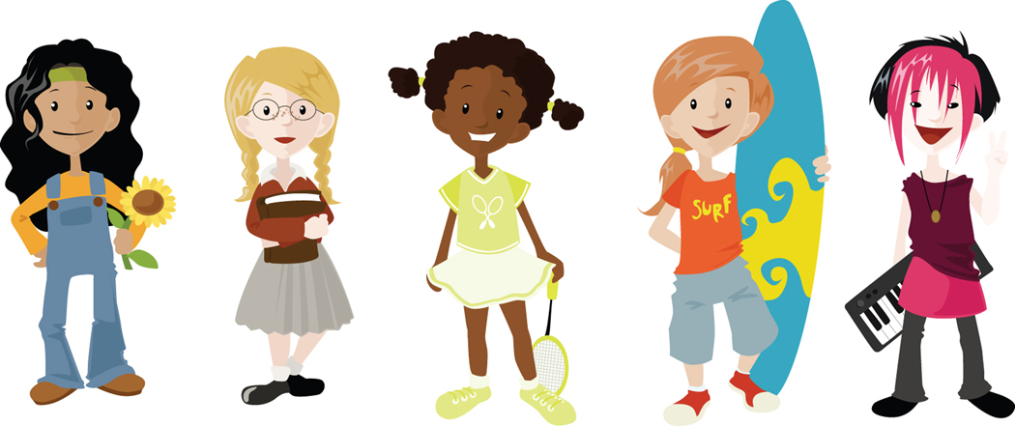
We have had a great week in Reception! We have been learning all about people who help us. Ask us and we can tell you all about them and the special jobs that they do ☺ We have used the internet to find information about people who do important jobs to help us and have read a lot of non-fiction books to get even more information. We have been learning the difference between fiction and non-fiction books and how we can use the contents page to make reading a non-fiction book easier. In Maths we have been learning all about shapes and talking about their properties and how we tell them apart, we went all the way up to a decagon ..( ten sided shape ☺) We have also been using a number square to 100 to count in tens and fives… We are very clever! We have been thinking about how God made us all unique and how this makes us special. We learnt a special action rhyme to help us remember. We have been working hard in our groups, labelling a picture of a police officer and what special equipment they have on their uniforms. We have been writing thank you cards to these special people. We have tried hard to think about the sounds that we need for the words and to write them. We had fun helping Miss Carr make a police car!

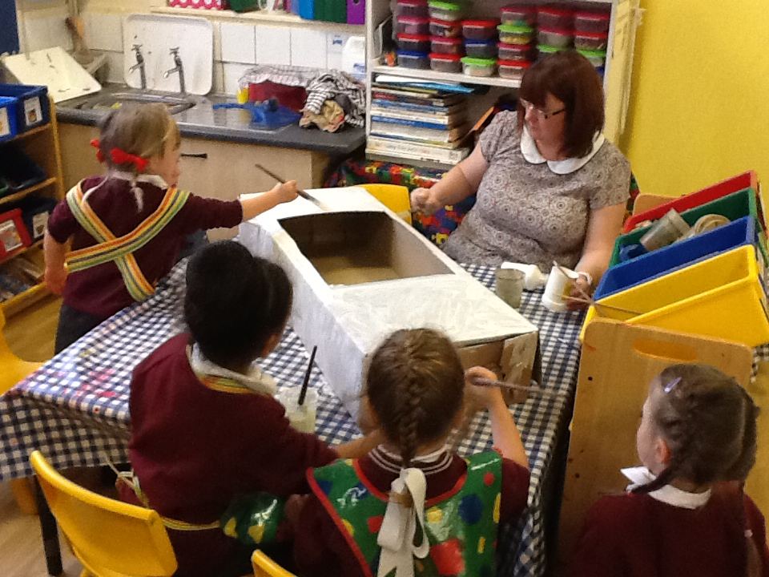

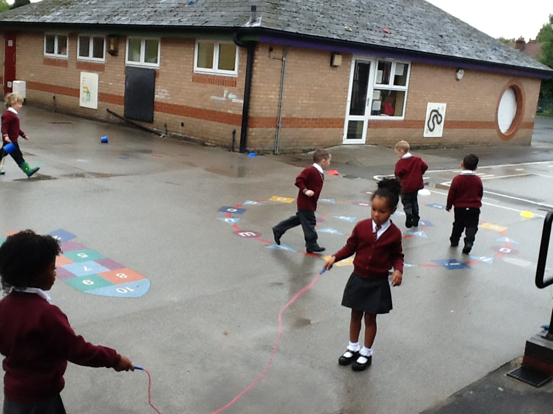
Home Learning: Using an Orbit ‘postcard’ or your child’s Learning Journey, please provide us with evidence that your child: can recognise 2D shapes in the environment and talk about their properties.
Letters and sounds : We have learnt the letter sounds ‘I’ ‘n’ ‘m’ ‘d’ please help your child by practising in their sound books.

Stars of the week

Reception 1 – Ava for being a really nice friend ☺
Reception 2 –Antonio for trying really hard in phonics this week ☺

NOTICE BOARD
Any letters sent home will be placed in the outside notice board. If you for any reason you miss a letter, please see you child’s teacher.
- In the Morning please encourage the children to line up on the main playground in their class lines. Can we ask all parents to stand out of the line to the side so that we can walk our children safely into class. Once we are in the classroom we begin our morning learning, so if you are late please take your child to the main reception office to be signed into school.
- Some children are still not bringing P.E kits to school; please ensure all children have it in for Friday.
- Please ensure all children have their sound books in school by Friday to enable us to keep up to date with their progress and give new sounds.
- Thank you for your continued support, Miss Moran, Mrs Breen, Miss Carr and Mrs Heitzman ☺

