Our week
We have had a lovely first week back at school, it really has been delightful getting to know all of your children and they have all been superstars settling in so well. Don’t worry if your child is still a little upset in the morning, please believe us when we tell you the crying stops almost immediately once they are inside. This week has been all about getting to know each other, exploring our new environments and getting to know the class and school routines. We have had some daily short carpet sessions where we have been practising our “good looking, good listening and good sitting!” For Literacy we have been sharing stories about starting school. In Maths we have been looking at numbers to 5 and singing counting songs. In Religion we have been talking about our new class family. On Wednesday we had music with Mrs Ali and on Thursday we had PE/Dance with Miss Morrison and Miss Fletcher (this will be the same every week for this half term.) Thank you for your patience and social distancing at drop off and pick up times, we hope that we soon will be able to get to know all the parents and carers a bit better! If anyone would like any information on the curriculum we have put some information on the school website under the Reception Blog. We will also be sending this newsletter every Friday letting you know what we have been up to in the week.

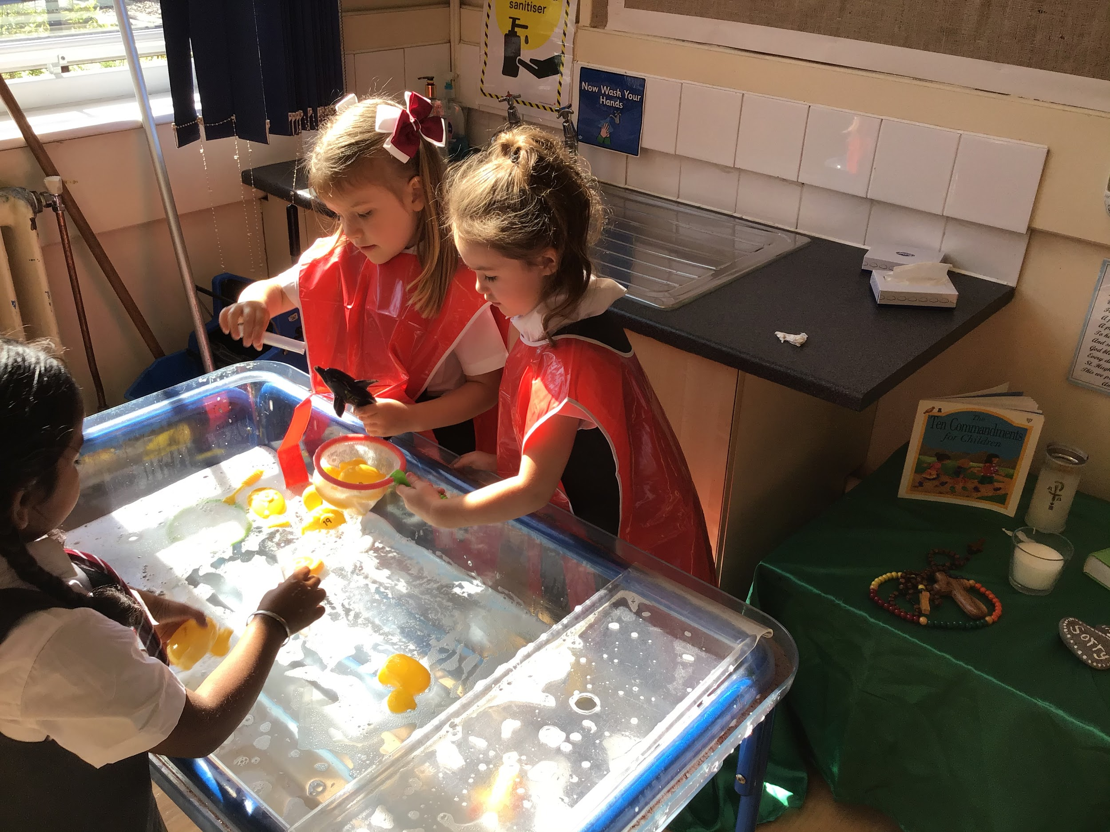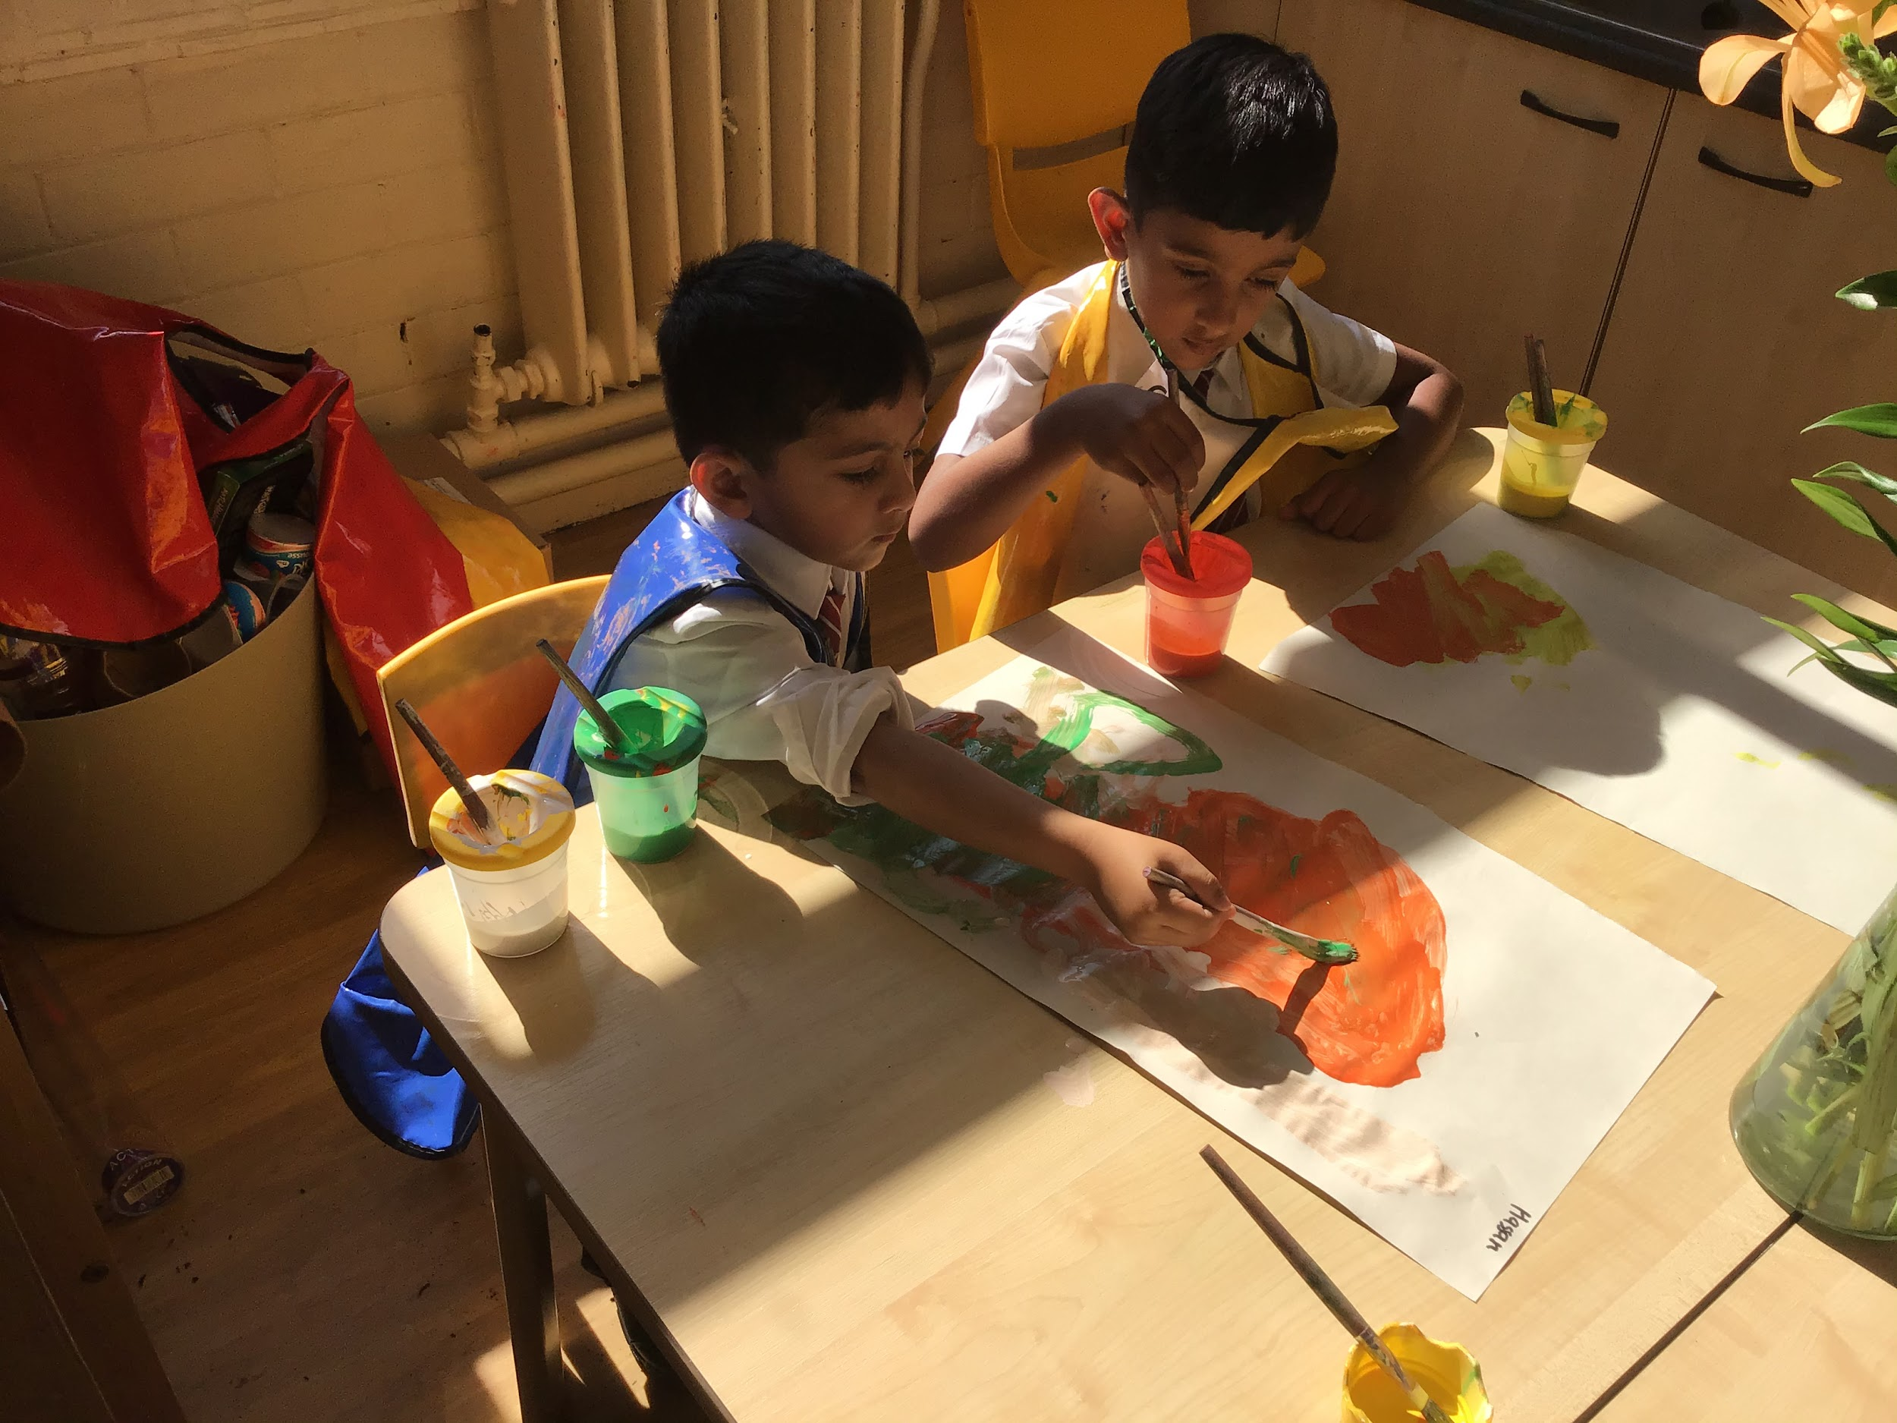
Home Learning :
Please support your child at home by pointing out numbers in the environment and sharing stories.

Stars of the week :

Rec 1- Macie for settling into Reception so well and always having a smile on her face!
Rec 2- Eliyanah for a great first week and always doing what she is asked to.

Everywhere Bear- Finn
Barnaby Bear - Oliver

Notices
*Children are asked to bring in a named water bottle and if they wish a piece of fruit or a vegetable for snack.
*Children need trainers or pumps for PE on a Thursday.
*Please label all items of clothing/shoes/trainers etc
*We also ask for a voluntary contribution of £1 per week to buy additional resources for our creative activities, special celebrations and baking. This can be sent in weekly on a Monday or every half term. This half term is 6 weeks so will be £6 if you can.
Many thanks for your support,
Mrs Doherty, Mrs Breen and Mrs Neville.

